**ACTIVITY 2.2:** **Basic SQL Command – No constraints and Referential Integrity**

***-------------------------------- [DML-Records Manipulation] -----------------------------***

***INSERT STATEMENT is used to insert a single record or multiple records into a table in MySQL.***

**SYNTAX**

In its simplest form, the syntax for the INSERT statement when inserting a single record using the VALUES keyword in MySQL is:

*INSERT INTO table (column1, column2, ... )**VALUES (expression1, expression2, ... ), (expression1, expression2, ... ),...;*

***Example:***

* 1. If you have the following table definition, here’s how you do it.

|  |  |  |  |
| --- | --- | --- | --- |
| Pet_id | Pet_name | Pet_gender | Pet_age |

***Insert into tbl_pet values (1, ‘Nymeria’,’female’, 5);***

***Your table would become:***

|  |  |  |  |
| --- | --- | --- | --- |
| Pet_id | Pet_name | Pet_gender | Pet_age |
| ***1*** | ***Nymeria*** | ***female*** | ***5*** |

* 1. By using SELECT command, you are able to display the records containing in the **tbl_pet** table. As you wish, invoke the following statement:

***SELECT *from tbl_pet;***

***That’s it, easy!***

* 1. What if you want to insert 2 or more than rows or records? Here’s how.

***Insert into tbl_pet values (2, ‘Lee Tsu Non’,’male’, 15), (3, ‘Kelly Cally’,’female’, 16);***

***Your table would become:***

|  |  |  |  |
| --- | --- | --- | --- |
| Pet_id | Pet_name | Pet_gender | Pet_age |
| 1 | Nymeria | female | 5 |
| ***2*** | ***Lee Tsu Non*** | ***male*** | ***15*** |
| ***3*** | ***Kelly Cally*** | ***female*** | ***16*** |

***Or if you want to store only specific value or fields to your table, you do this:***

***Insert into tbl_pet (pet_id, pet_name, pet_age) values (2, ‘Anne ann’, 12);***

***Your table would have additional information about Anne:***

|  |  |  |  |
| --- | --- | --- | --- |
| Pet_id | Pet_name | Pet_gender | Pet_age |
| ***2*** | ***Anne ann*** |  | ***12*** |

* 1. Using your **tbl_pet** table, store these values as an additional record:

|  |  |  |  |
| --- | --- | --- | --- |
| Pet_ID | Pet_Name | Owner_Gender | Pet_Age |
| 1 | Amenadiel | Female | 5 |
| 4 | Lucifer Morningstar | Male | 4 |

*Now, show the records of your* ***tbl_pet*** *table using* ***SELECT*** *command.*

**My command prompt:**

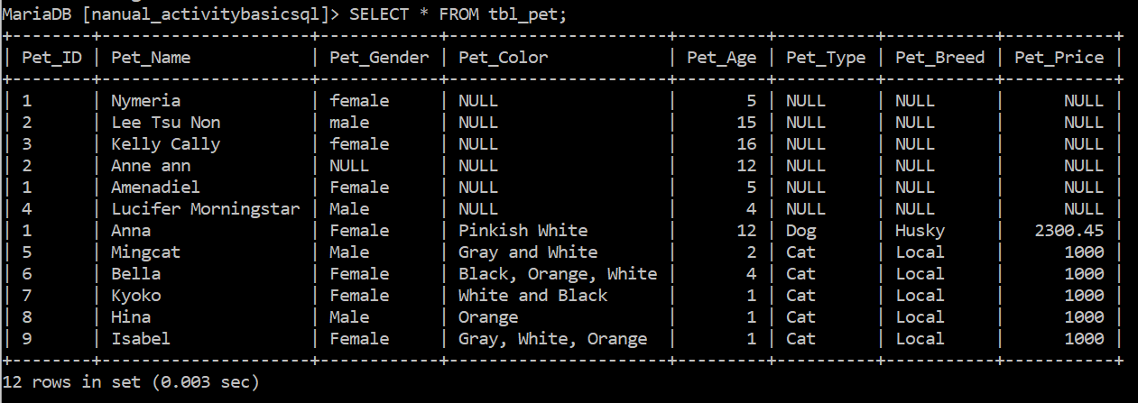

***NOTE: You will observe that you are able to store records having the same IDs even if they have different information. Hence, it is called data duplications and it must be avoided. For now, let us leave it as it is. We will have another activity intended for that purpose.***

* 1. You just tried removing **tbl_buyer** table from your previous using **DROP** command. This time I want you to use **TRUNCATE TABLE** command. To do it see below:

***TRUNCATE TABLE tbl_pet;***

**My command prompt:**

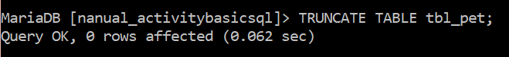

***NOTE: You will observe that all of the records of your table tbl_pet is now gone but NOT the tbl_pet. Unlike when you use DROP command, the table all of its records are all eradiated from the database. For your information DROP and TRUNCATE commands are belonged to DDL SQL.***

1. Using your **tbl_owner** table, store these values: ***1,” Cain”, “Davao City”, “female”, 2229614.***

***Your table should become:***

|  |  |  |  |  |
| --- | --- | --- | --- | --- |
| ***Owner_ID*** | ***Owner_Name*** | ***Owner_Address*** | ***Owner_Gender*** | ***Owner_Contact*** |
| ***1*** | ***Cain*** | ***Davao City*** | ***Female*** | ***2229614*** |

**My command prompt:**



1. Show records of your **tbl_owner** table using **select** statement. Invoke the SQL statement below to accomplish the task:

***SELECT *from tbl_owner;***

***You should have shown like this:***

|  |  |  |  |  |
| --- | --- | --- | --- | --- |
| ***Owner_ID*** | ***Owner_Name*** | ***Owner_Address*** | ***Owner_Gender*** | ***Owner_Contact*** |
| ***1*** | ***Cain*** | ***Davao City*** | ***Female*** | ***2229614*** |

**My command prompt:**

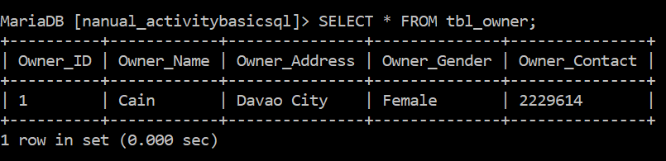

1. Using the **tbl_pet** table, store these information (sequence):

***1, “Anna”, “Female”, “Pinkish White”, 12,’Dog’,”Husky”, 2300.45***. ***(Show your records after)***

***Your table should have become:***

|  |  |  |  |  |  |  |  |
| --- | --- | --- | --- | --- | --- | --- | --- |
| Pet_ID | Pet_Name | Pet_Gender | Pet_Color | Pet_Age | Pet_Type | Pet_Breed | Pet_Price |
| 1 | Anna | female | Pinkish White | 12 | Dog | Husky | 8900.00 |

**My command prompt:**

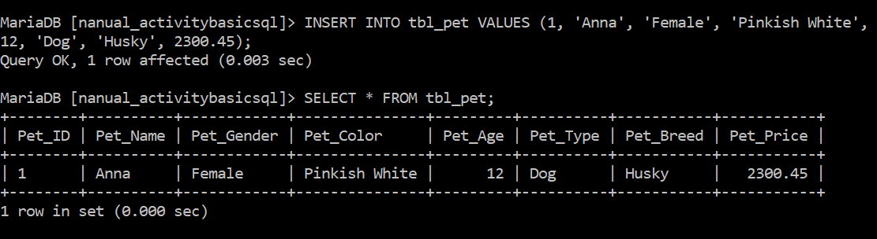

1. Insert information for **tbl_pet** atleast 5 of your own specifications and preference.

**My command prompt:**

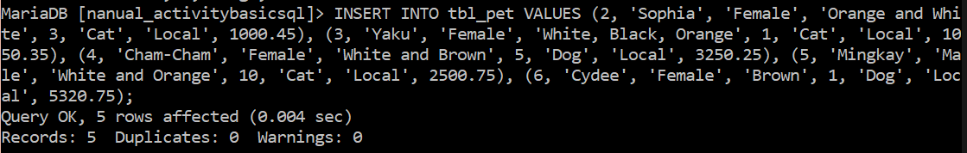

1. Insert the following information to your **tbl_pet**:

(***Look at the table below carefully of what columns or fields are used upon storing values.***)

|  |  |  |  |
| --- | --- | --- | --- |
| Pet_id | Pet_name | Pet_gender | Pet_age |
| 1 | Nymeria | female | 5 |
| 2 | Lee Tsu Non | male | 15 |
| 3 | Kelly Cally | female | 16 |
| ***4*** | ***Anne ann*** |  | ***12*** |

**My command prompt:**

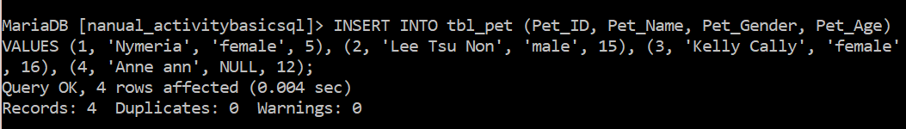

***NOTE: Observe that you are able to store information of pet having the same Pet_id since it wasn’t specified as primary key. Hence, duplication is possible.***

1. Display all fields from the table **tbl_pet. [DDL].**

**My command prompt:**

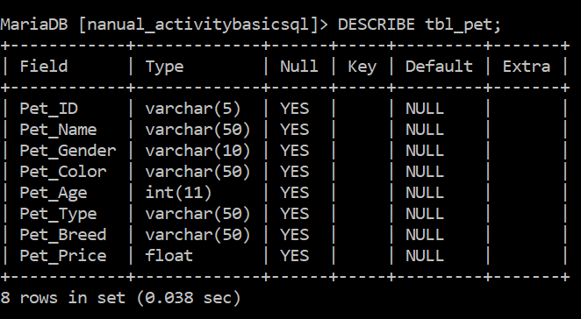

1. Show records of your **tbl_pet.**

**My command prompt:**

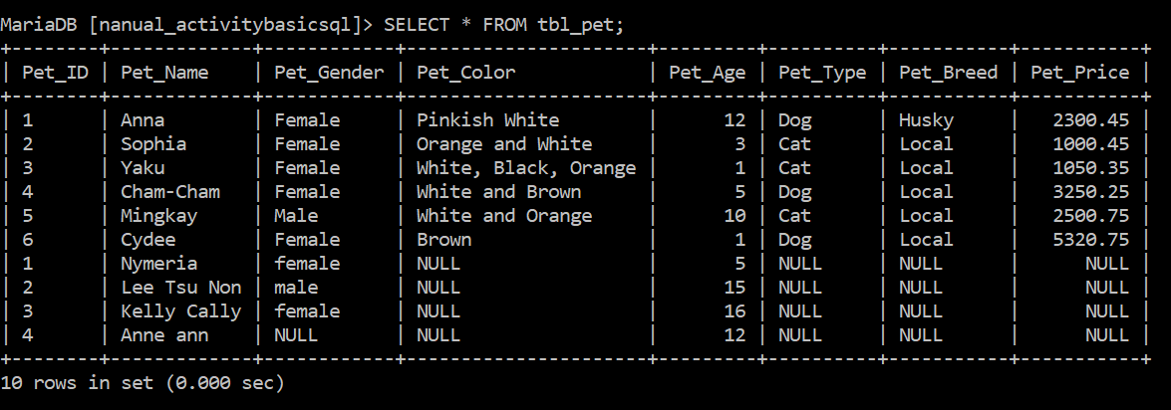

1. Insert information to your table **tbl_owner** atleast 3 of your own specifications and preference.

**My command prompt:**

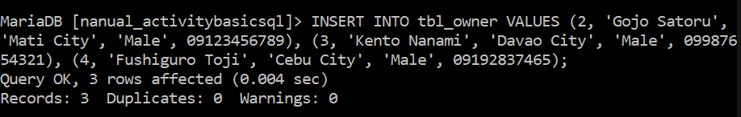

1. Show records of your **tbl_owner.**

**My command prompt:**

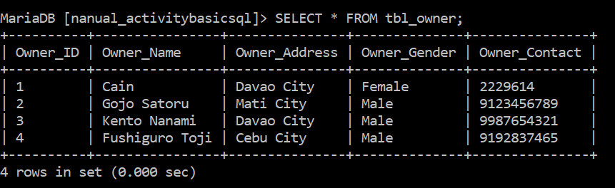

1. Display data dictionary of **tbl_owner and tbl_pet. [DDL].**

**My command prompt:**

